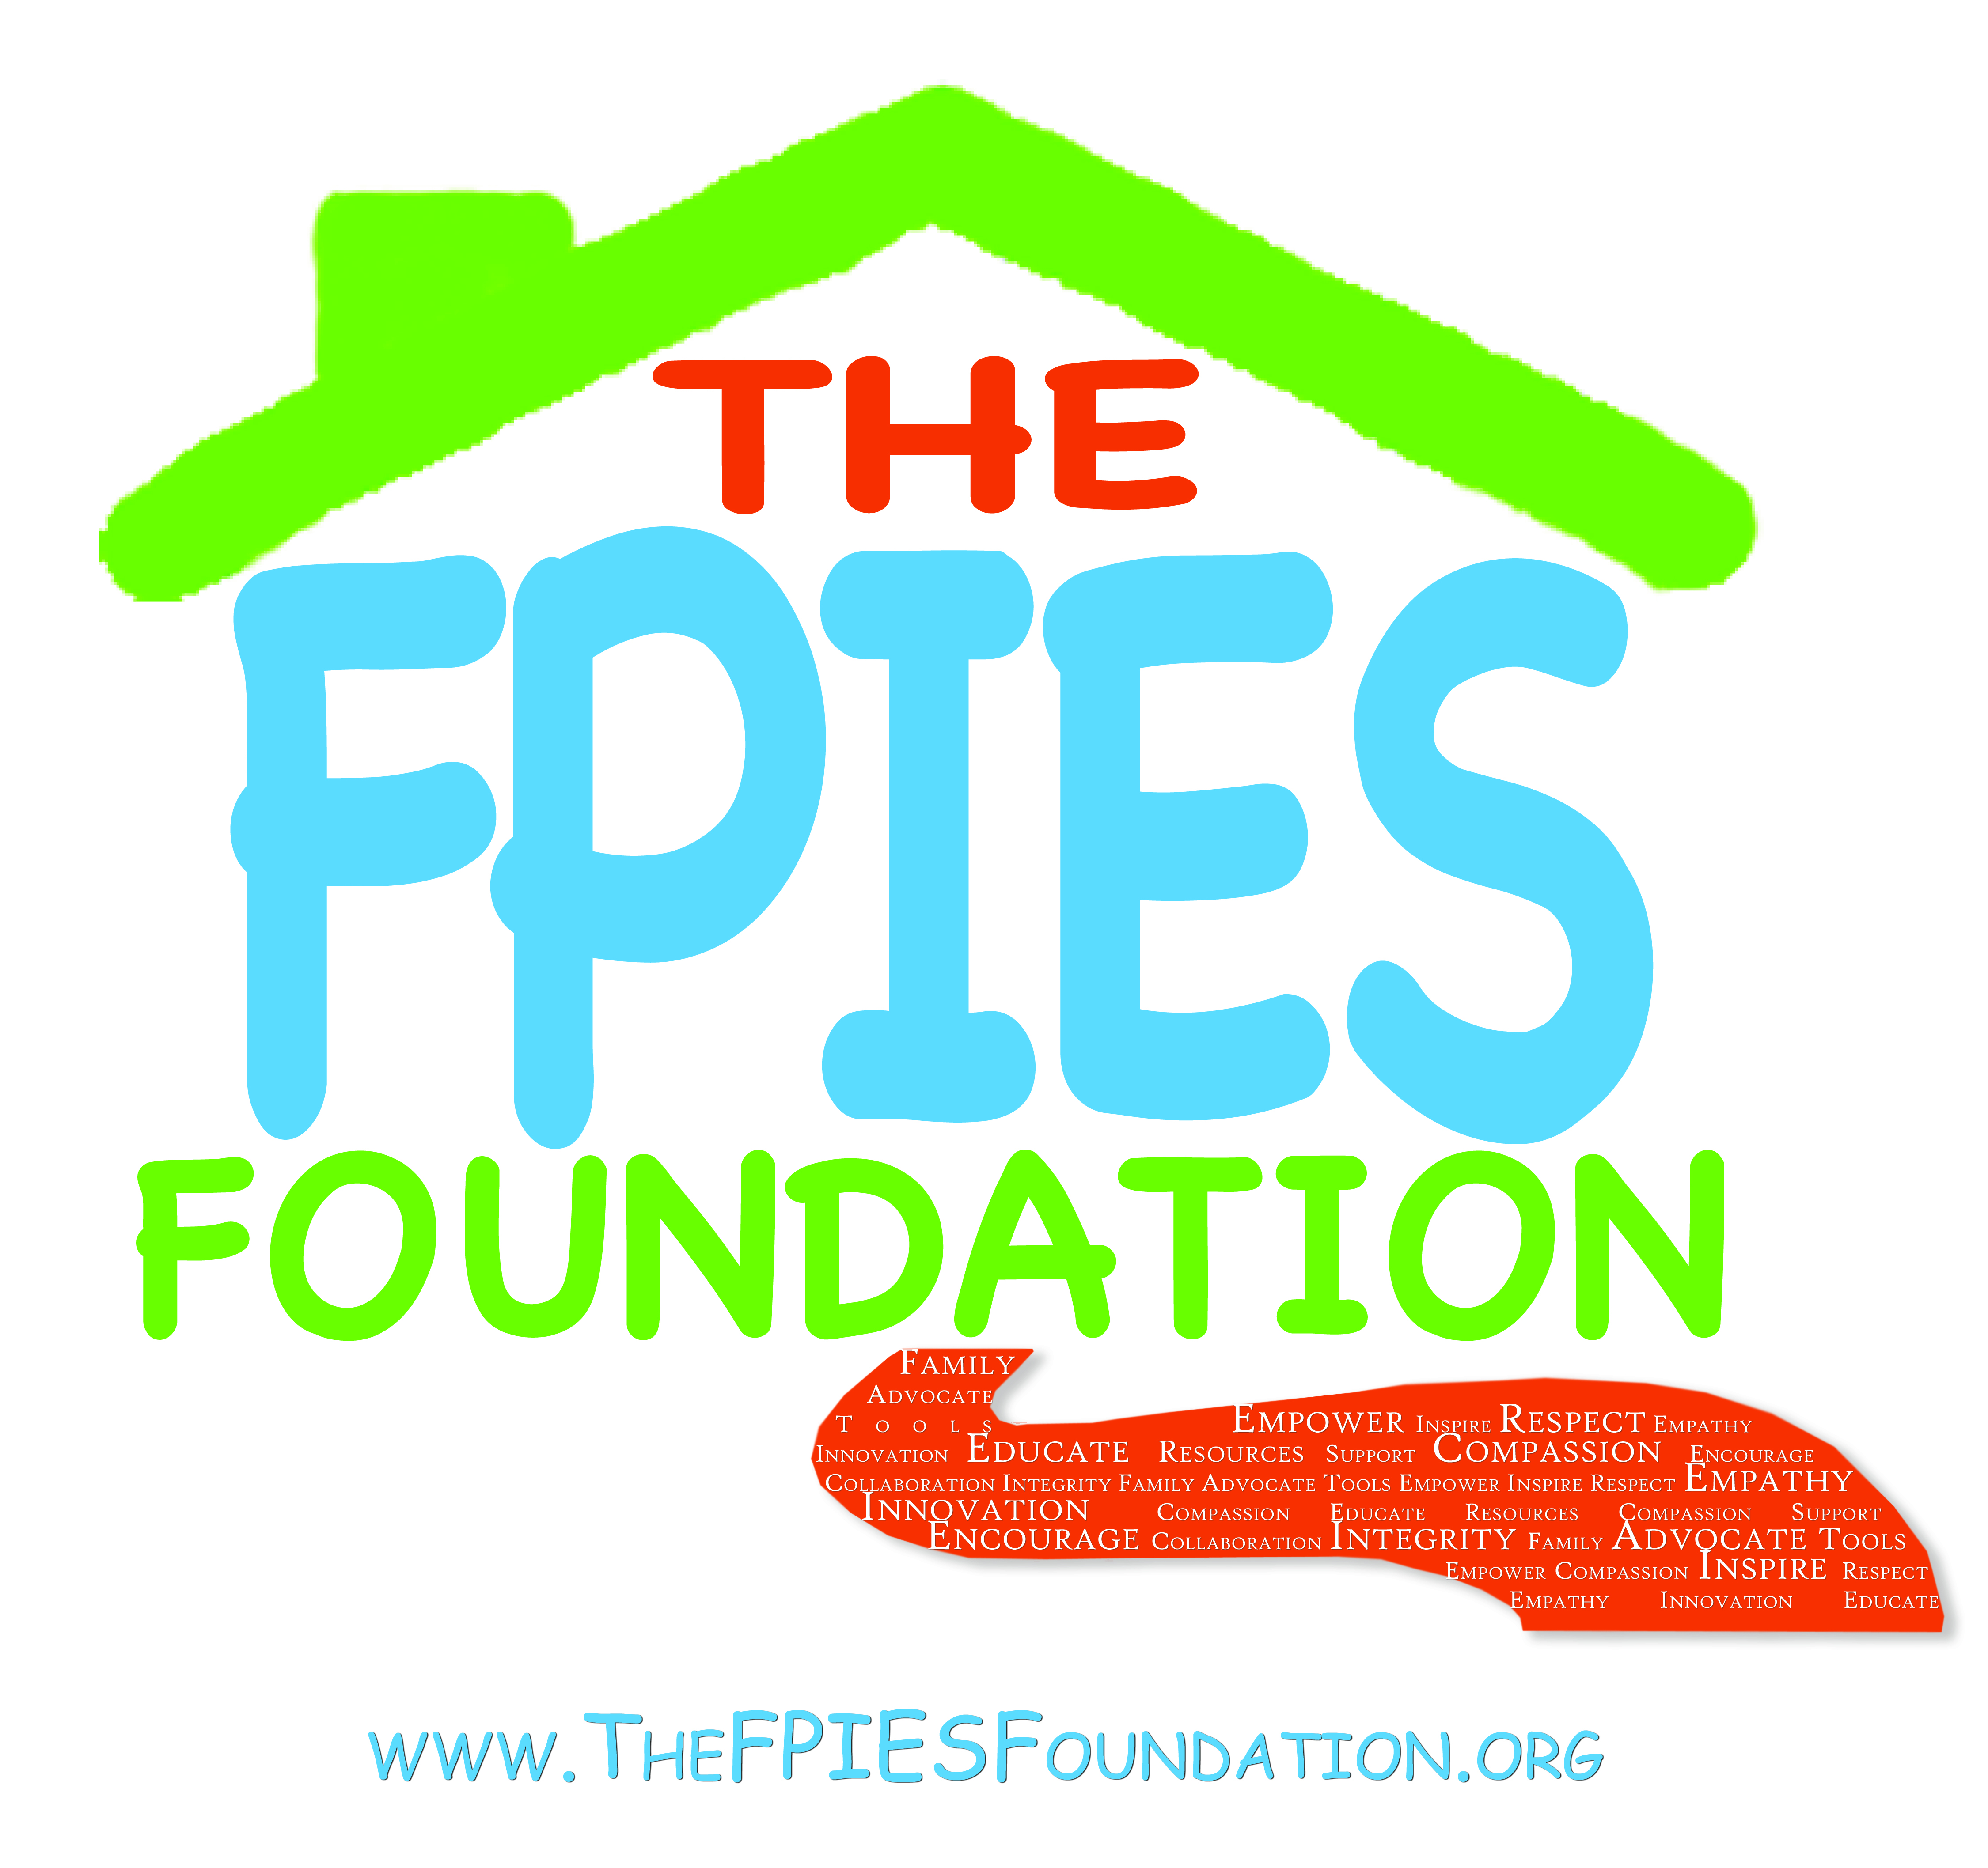

The FPIES Foundation Volunteer Handbook
Volunteer Application
Volunteer Agreement
Volunteer Job Description
Code of Ethics (included in job description)
Conflict of Interest (Code of Ethics)
Volunteer Confidentiality Agreement
The FPIES Foundation Orientation (About/Mission/Vision/Values, and including o organizational structure)
Volunteer Self Evaluation
Volunteer Member Removal Policy
Project proposal Guidelines
Committee Guidelines (when/where applicable)

